**Section 1: Hyperledger Fabric Refresher**

Hyperledger is not a single project but a collection of projects under the Hyperledger Initiative.

There are two types of projects.

1. **Frameworks:** These are the distributed ledger technology frameworks.

Hyperledger Fabric is a distributed ledger technology framework.

1. **Tools:** Hyperledger Composer is a tool that can accelerate the development of applications on Hyperledger fabric.

The expectation for the tools is that they will work across the various distributed ledger technology frameworks.

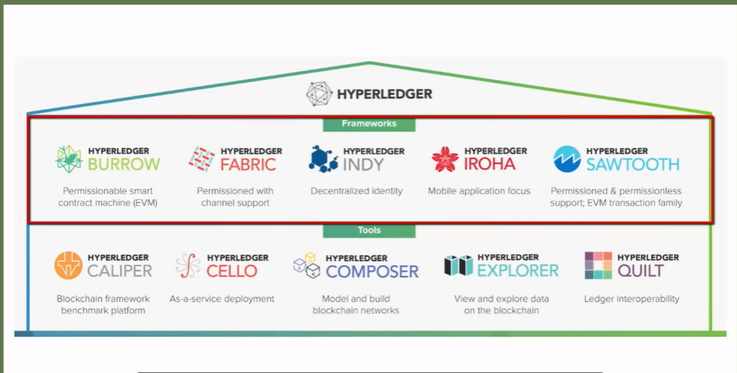

**“Hyperledger Fabric is a distributed ledger technology framework for building business blockchain applications.”**

**Distributed ledger technology for the Business**

There are **four** aspects of Hyperledger fabric distributed ledger technology that makes it suitable for implementing blockchain applications for business, **permissioned network, confidentiality of the transactions**. No need for cryptocurrency, for transactions and programmability.

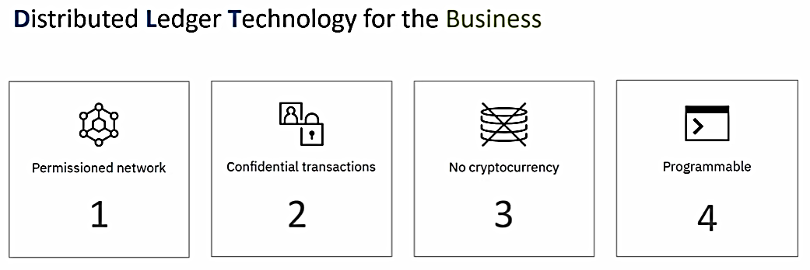

1. **Permissioned blockchain**

 the participants don't have to reveal their identity. They can just download a software and start transacting on the public network.

In the case of a business application, anonymity is not the way things work.

* Member entities are known
* Participants have role based access

Hyperledger Fabric is a permissioned network in which identities are managed and roles are assigned.

1. **confidential transactions**

In the case of a public blockchain network, all transactions are visible to everyone.

In the case of a business blockchain network, it may not be a desirable thing.

Sometime businesses like to keep their transactions confidential and visible only to the counterparty.

Hyperledger fabric based blockchain network allows the members to transact privately.

That means their transactions are visible only to the counterparties and are not visible to the other members on the network.

* Not all transactions visible to all
* Members can transact privately

1. **No cryptocurrency**

in the case of a public blockchain network, transactions are validated by the members of the network in return for crypto tokens and that is the incentive which keeps the public networks going.

In the case of a business, blockchain network, cryptocurrency or crypto token based incentivization is not needed.

* No incentivization needed.
* No crypto token needed for transactions

1. **programmable**

Also, in the case of a **business blockchain** network, there is no need for crypto tokens to be given bout as a fee for the execution of the transactions.

Hyperledger Fabric does not have the concept of cryptocurrencies.

For that reason, Hyperledger Fabric supports **smart contracts or the chain codes.**

The chain code encapsulates the business logic for the implementation of the business blockchain application.

* Smart contract
* Business logic implementation

**Summary**

To summarize,

* Hyperledger refers to the project under Linux Foundation and
* Hyperledger Fabric is a **distributed ledger technology framework**, which is one of the projects under the Hyperledger Initiative.
* Hyperledger Fabric is built ground up for creating business blockchain applications.
* There are four aspects that make it suitable for business blockchain applications.
* It supports Permissioning, it supports confidential transactions.
* There is no need for cryptocurrency for incentivization as well as for the transaction execution.
* And you can build business logic and chain code

**Hyperledger Fabric Architecture and Components**

All blockchain technologies have this concept of nodes.

Nodes connect to each other to form the blockchain network.

In public, blockchain networks such as Ethereum and Bitcoin, all nodes are equal,

but in the case **of Hyperledger Fabric**, all nodes may not be equal in the Hyperledger fabric distributed ledger technology or blockchain technology.

There is a concept of members. **Members=Legal entities**

Members are legally separate entities that join the blockchain network to transact.

These members share one or more distributed ledgers and each of these members host nodes.

These nodes are used for:

* submitting the transactions and
* for managing the state of the ledger within the organization.